Big Data Analytics
3. NoSQL
3.1 Introduction to NoSQL, NoSQL Business Drivers.
3.2 NoSQL Data Architecture Patterns: Key-value stores, Graph stores, Column family (Bigtable) stores, Document stores, Variations of NoSQL architectural patterns, NoSQL Case Study.
3.3 NoSQL solution for big data, Understanding the types of big data problems; Analyzing big data with a shared-nothing architecture; Choosing distribution models: master-slave versus peer-to-peer; NoSQL systems to handle big data problems. peer-to-peer; Four ways that NoSQL systems handle big data problems.
PAST QUESTIONS:
- Explain the four types of NoSQL database. (D23)
- Explain Column family store and Graph Store NoSQL architectural pattern with example. (M24)
- Differentiate between SQL vs NoSQL. (D24, M25)
- Compare different types of NoSQL architectural pattern. (D24)
- Explain Key-value store and Document Store NoSQL architectural pattern with example. (M25)
- Four ways that NoSQL systems handle big data problems. (M25)

NOTES:

*Four types of NoSQL Database :-
Databases store data in an organized manner for easy access and management. Traditional relational databases use structured tables, but modern applications and big data have driven the rise of NoSQL systems.
NoSQL databases (aka "not only SQL") are non-tabular databases and store data differently than relational tables. NoSQL databases come in a variety of types based on their data model. The main types are document, key-value, wide-column, and graph. They provide flexible
schemas and scale easily with large amounts of data and high user loads.

1. Key-value store –
A key-value store is a nonrelational database. The simplest form of a NoSQL database is a key-value store. Every data element in the database is stored in key-value pairs. The data can be retrieved by using a unique key allotted to each element in the database. The values can be simple data types like strings, numbers or complex objects.
However, keys must be unique. This means this type of database is best when data is attributed to a unique key, like an ID number.
For example, let’s say we wanted to store shopping cart information for customers who shop in an e-commerce store. Our key-value database might look like this:
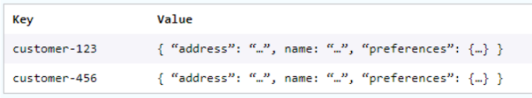
Popular Key-value databases which are widely used are: Couchbase, Amazon DynamoDB, Riak, Aerospike, Berkeley DB, Redis.
Key features:
- Simplicity: It is very easy to use. Due to the simplicity of the database.
- Speed: Its response time is fast due to its simplicity, ideal for caching and real-time applications.
- Scalability: Key-value store databases are scalable vertically as well as horizontally.

2. Graph Based Database –
Graph-based databases focus on the relationship between the elements. It stores the data in the form of individual nodes in the database and establishes connections between the nodes called as links or relationships, making them ideal for complex relationship-based queries.
This data models give us a conceptual view of the data.
For example, let’s say we wanted to build a recommendation engine for our e-commerce store. We could establish relationships between similar items our customers searched for to create recommendations.
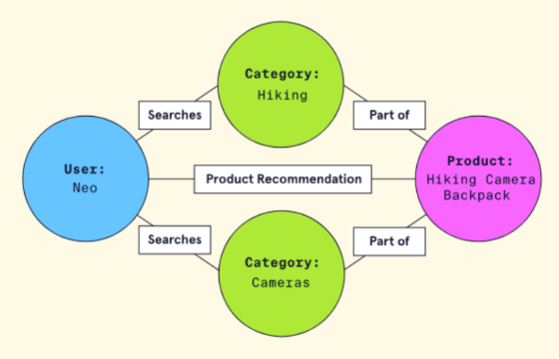
Popular Graph Databases: Neo4j, Amazon Neptune, ArangoDB.
Key Features:
- Relationship-Centric Storage: Perfect for social networks, fraud detection, recommendation engines.
- Real-Time Query Processing: Queries return results almost instantly.
- Schema Flexibility: Easily adapts to evolving relationship structures

3. Column Oriented Database –
A column-oriented database is a non-relational database that stores the data in columns instead of rows. Columnar databases are designed to read data more efficiently and retrieve the data with greater speed. A columnar database is used to store a large amount of data.
For example, take a look at the following e-commerce database of products:
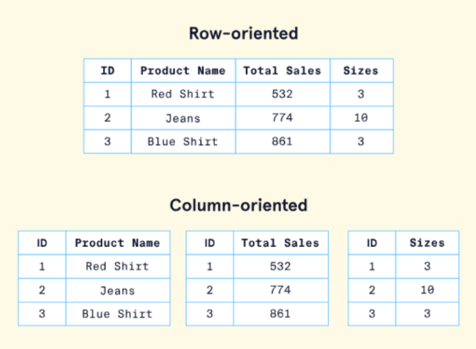
If we wanted to analyze the total sales for all the products, all we would need to do is aggregate data from the sales column.
Popular Column Oriented Databases used widely: Apache Cassandra, Google Bigtable, HBase, Amazon Redshift.
Key Features:
- High Scalability: Supports distributed data processing.
- Compression: Columnar storage enables efficient data compression.
- Faster Query Performance: Best for analytical queries.

4. Document Based Database –
A document-based database consists of data stored in hierarchical structures. Instead of storing the data in rows and columns (tables), it uses the documents to store the data in the database. Some supported document formats include JSON, BSON, XML, and YAML. The document-based model is considered an extension of the key-value database and provides querying capabilities not solely based on unique keys.
Documents are considered very flexible and can evolve to fit an application’s needs.
For example, let’s say we wanted to store product information for customers who shop in our e-commerce store. A products document might look like this:

Popular Document Based Databases that are widely used: MongoDB, Firebase Firestore.
Key Features:
- Flexible schema: Documents in the database has a flexible schema. It means the documents in the database need not be the same schema.
- Faster creation and maintenance: the creation of documents is easy and minimal maintenance is required once we create the document.
- No foreign keys: There is no dynamic relationship between two documents so documents can be independent of one another. So, there is no requirement for a foreign key in a document database.
- Open formats: To build a document we use XML, JSON, and others.

*SQL vs NoSQL :-
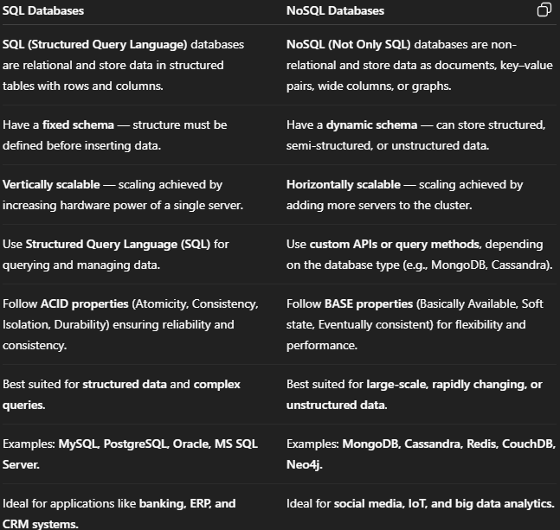

*Four ways that NoSQL handles Big Data Problems :-
